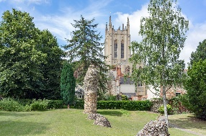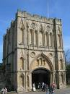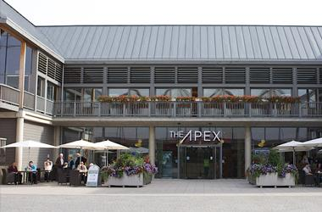 | The Bury St Edmunds – Compiegne  Twinning Association

July 2022 Newsletter

Dear Friends,

All our members who were able to take part in the first exchange since 2019 were able to enjoy a very successful weekend. However, several of our French friends were prevented from travelling due to Covid and other health problems, which was a huge disappointment to those hoping to receive their guests. It was clear that the long wait for this exchange had changed nothing for our established twin friendships and the newly arranged pairings were also very successful. Thank you to all who welcomed guests into their homes and to Maria Broadbent for looking after the coach driver. It is to be hoped that those exchanges which could not take place this year will be re-kindled with the visit to Compiegne on May 26-29th 2023.

We can however be sure that the 30 French visitors made the most of their time with their hosts. The Saturday trip to Sutton Hoo proved to be an interesting outing, with help from unexpectedly dry sunny weather. The members enjoyed picnics in the grounds and were able to visit a special exhibition of stunning Anglo Saxon jewellery and other artefacts, as well as touring the house formerly owned by Edith pretty and viewing the mound where the ship was found buried.

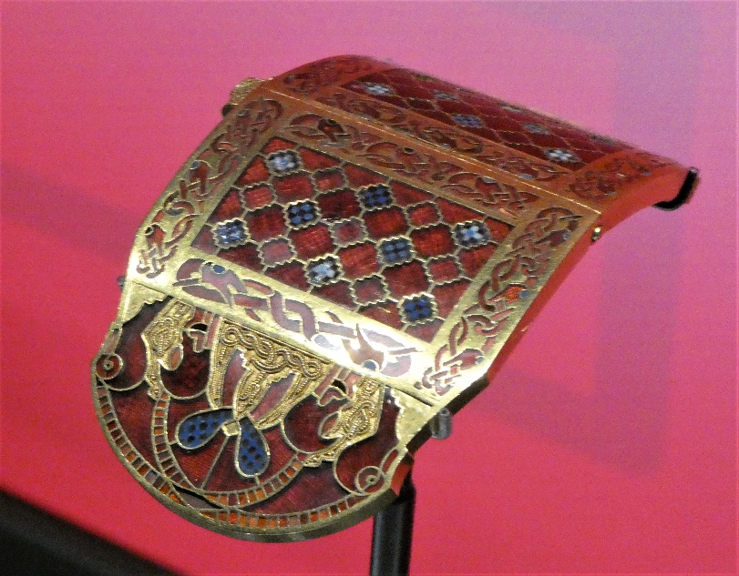 | 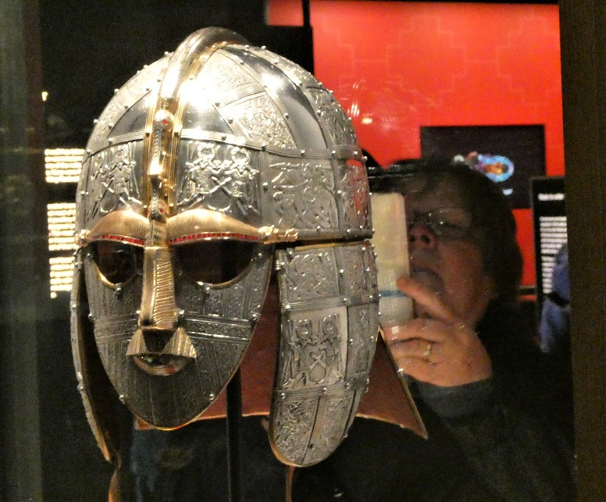

The coach returned in good time to prepare for the Reception and Supper at the Guildhall in the evening. The party assembled for aperitifs and nibbles in the lovely garden behind the Guildhall. We were very pleased that Bury St Edmunds Mayor Cllr Thompson was able to join us and to make the welcoming speech to our guests. Our meal, catered by Roffs, was excellent and the Burgundy wines sourced by Sally and Phil were greatly appreciated. Sunday, being the day on which street parties were being held to celebrate the Royal Jubilee, members entertained their guests at their local parties or with other trips. A small group made a tour around the brewery with Helen Korfanty our Twinning Secretary.

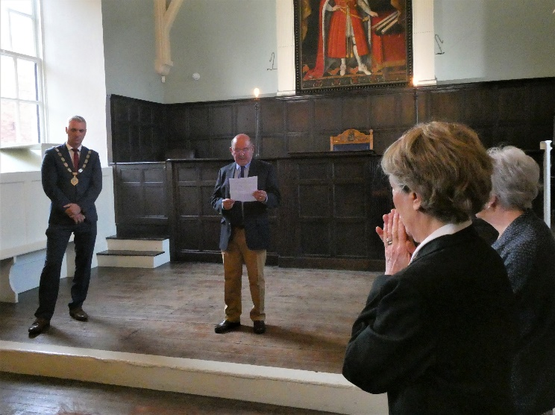 | 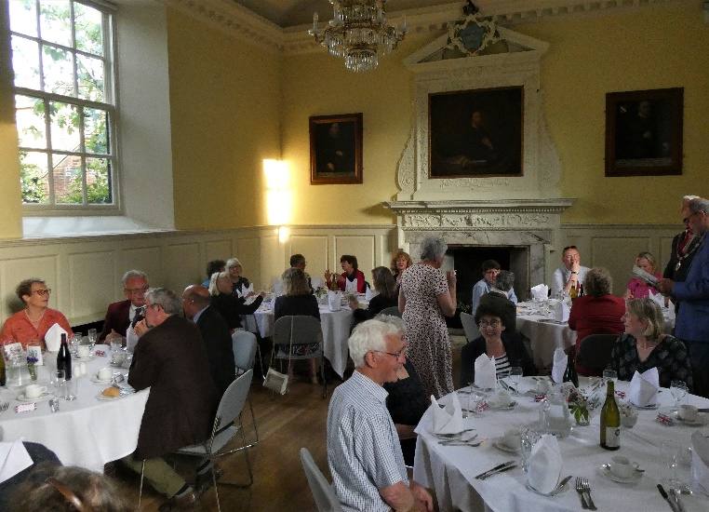

The happy faces alongside the French coach at departure on the Monday morning confirmed that the visit was very much enjoyed.

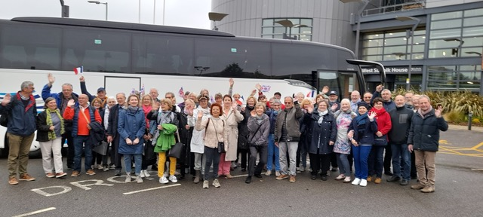

Website:

The Friends of Compiegne now have a website, designed by Phill Smith. To keep up with news and events visit Home (friendsofcompiegne.org.uk)

Diary Dates for Upcoming Events:

After recovering from the visit, your Committee are planning some events to look forward to:

AGM & Dinner: Friday Oct 7th. At Casa. £29.95 per person to include welcome drink and nibbles, a full sharing menu (veg, non veg and other diets catered for) and mini desserts. Booking details to follow.

Conversation Morning: Saturday 12th November at Risbygate Sports Club. 10.30 to noon. £5 each including croissants and tea/coffee. For more details contact Isabel Lorimer.

Film Club: We intend to organise another French Film showing in late November with Bury Film Society.

Christmas Social: At Risbygate Sports Club, Saturday 3rd December at 7:30pm. More information to follow.

